**DESIGN AND ANALYSIS OF GRID CONNECTED PV/HYDRO/FC (FUEL CELL) HYBRID SYSTEM BATTERY AND PHS STORAGE SYSTEM TOWARDS ENERGY HARVESTY IN UNIVERSITY CAMPUSES**

**CHAPTER ONE**

**INTRODUCTION**

* 1. **BACKGROUND TO THE STUDY**

Currently, with the enormous demand for electricity this research focus on integrating multiple renewable energy sources to help mitigate power deficiency and green house emission associated with non-renewable energy. With urgent necessity to balance fossil fuel depletion and reduce green house gas emissions, the world is going towards clean and efficient power sources, such as renewable (Photovoltaic, wind, biomass, fuel cells and hydro). The power generations using the renewable energy systems are rapidly becoming more efficient and cheaper and their share of total energy consumption is increasing (Deloitte 2019).

The hybrid power plant is a complete electrical power supply system that can be easily configured to meet a broad range of remote power needs which in this research study focus on university campuses. Solar/wind, hydro/wind, wind/diesel, solar/thermal/biomass etc., are well known hybrid power generation systems.

The hybridization of renewable energy system is possible, as per the availability of renewable energy sources in the particular areas. The solar energy is omnipresent energy source. The energy conversion from solar energy to electrical energy via PV array is the only solution for better as well as cleaner energy as it naturally harnesses the sun energy (Mashram 2013). The only disadvantage of the solar energy system is that it cannot generate the power in cloudy/rainy days and at night. The performance of the solar energy system can be improved by integrating the other energy system such as wind power generation system and diesel generator with energy storage (Meshram 2013). The wind power generation is not sufficient in the area under consideration (university campuses in southern Nigeria), and diesel generation is non-renewable. Hence, with these systems continuous power flow is not possible. Optimal results can also be obtained from PV system combined with the hydro power plant and fuel cell (FC) energy.

Fuel cell is an electrochemical cell that converts the chemical energy of fuel (often hydrogen) and an oxidizing agent (often oxygen (Siakia 2018)) into electricity through a pair of redox reactions (Khurmi 2014), and it can be integrated in a hybrid system with the solar and hydro electricity. Fuel cells are batteries but are different from most batteries in requiring a continuous source of fuel and oxygen.

Both solar power and fuel cell power are variable renewable energy (Ghenai 2019), meaning that all available output must be stored (for example, in a battery) or taken whenever it is available by moving through transmission lines to be used. However, solar energy has great seasonal and diurnal variations, especially at high and middle latitudes. Hence, the storage of solar energy in suitable form which can then be conventionally converted into the required form (Dimitriev 2020) is applied.

Conventional hydroelectricity works very well in conjunction with solar power; water can be held back, released from a reservoir as required. Where suitable river is not available, pumped storage hydroelectricity or pumped hydroelectricity storage (PSH or PHS) uses solar power to pump water to high reservoir on sunny days, then the energy is recovered at night and in bad weather by releasing water via a hydroelectric plant to a low reservoir where the cycle can begin again (ESA 2008).

In stand-alone PV systems batteries are traditionally used to store excess electricity. With grid-connected photovoltaic power system, excess electricity can be sent to the electric grid. Batteries used for grid storage can stabilize the electrical grid by leveling out peak loads for around an hour or more.

The combination between photovoltaic (PV), fuel cell (FC) and hydro electricity hybrid system is studied in this research work, also included is the different storage method which are the batteries and PHS (Pumped Hydroelectricity Storage) available for the grid connected hybrid system considered.

**1.2 STATEMENT OF THE PROBLEM**

Since the beginning of the twenty-first century, energy demand is rapidly increasing which is estimated to increase by 56% from 2010 to 2040 (Kabir 2020).

The energy supply crisis is the ongoing failure of the Nigerian power sector to provide adequate electricity supply to domestic households and industrial producers despite a rapidly growing economy as one of the world's [largest deposits of coal, oil, and gas](https://en.wikipedia.org/wiki/List_of_countries_by_proven_oil_reserves) and the country's status as Africa's largest oil producer. Currently, only 45% of Nigeria's population is connected to the energy grid whilst power supply difficulties are experienced around 85% of the time and almost nonexistent in certain regions (Aliyu 2013). Currently, Nigeria uses four different types of energy: natural gas, oil, hydro, and coal. The energy sector is heavily dependent on petroleum as a method for electricity production which has slowed down the development of alternative forms of energy. Three out of the four above resources used for energy production in Nigeria are linked with increasing [greenhouse gas emissions](https://en.wikipedia.org/wiki/Greenhouse_gas_emissions): coal, oil, and natural gas, with coal, emitting the worst of the three.

Since further development of only hydro-electricity might not seem practical because of the dependence on the seasons for amount of water supply (Ajayi 2009). The development of renewable sources of energy is important for the future of the country. The only thing that remains is to figure out which energy source is most practical for Nigeria.

The most practical solution was mentioned by Gujba, Mulugetta, and Azapagic, (2011). The authors of this article suggested that a harmonization of different forms of energy take place. In their sustainable development scenario, they suggested some reliance on renewable energy sources and a slow change from fossil fuels to renewable energy sources. For rural areas which are further from the electricity grid and most currently do not have power, and for commercial buildings, industries and university campuses; each area would become a little hub where they would produce their own power by whatever resource was closest. For example, in the northern areas, the mini-grids would work on wind and solar power energy. In the southern areas (which will be considered in this research), the mini-grids would work on solar and fuel cell energy or solar and hydro energy or a combination of solar, hydro and fuel cell energy. Hence, in this research, a hybrid power system consisting of PV, FC and hydro is studied integrated with a battery and PHS storage system. The hybrid system acts as a dominant system and power grid (the battery and PHS storage system) will act as a standby to compensate the deficit in the hybrid system. In rainy days/night, the solar energy will be unavailable, hence the power requirement will fulfilled by hydro system, fuel cell and power grid.

**1.3 SIGNIFICANT OF THE STUDY**

From the discussion above the significant of this study is listed below:

* Due to the fact that the national grid cannot provide reliable electricity for commercial use especially in our university campuses; this study therefore, focuses on the use of renewable energy system to power commercial building in this case the buildings in Ambrose Alli University campus.
* Fossil fuel is being used as the main or the primary fuel to generate electricity for these buildings. Hence energy generation using renewable energy resources and sustainable and renewable fuels can be used as alternative to the conventional fossil fuel based power systems.
* To provide a sustainable solution to the high energy consumption of these commercial buildings found in the university campuses.
* In this study the solar PV will be considered as the main source of energy while the fuel cell and hydro power can efficiently complement the fluctuating renewable resource of the solar PV system to satisfy the energy demand of the university campus.

**1.4 AIM AND OBJECTIVES**

The aim of this research study is: The Design and Analysis of a Grid connected PV/Hydro/FC (fuel cell) Hybrid System with Battery and PHS Storage System towards Energy Harvesting in University Campuses with focus on Ambrose Alli University Ekpoma Edo state.

The objectives of this research include:

* To review past works on renewable energy technology
* The design of PV/Hydro/Fuel Cell hybrid system
* The analysis of PV/Hydro/Fuel Cell hybrid system
* Consideration of renewable energy using battery and pumped hydro storage (PHS)

**1.5 METHODOLOGY**

In carrying out this research studies, the following methodology will be used;

Analytical Method: the analytical research is done by making critical evaluation of the problem and analyzing facts and information already available; hence the renewable sources of energy, grid connected hybrid system of different renewable energy sources, battery storage and PHS storage will be analyzed by making critical evaluation of the problem using facts and information already available.

Applied Method: the applied research is use to provide a solution for an immediate problem facing a society or an industrial / business organization; hence the applied method will be utilize in designing the grid connected Solar PV/Hydro/Fuel cell hybrid system with power storage for the university campuses located in the southern part of Nigeria with Ambrose Alli University as the main Focus therefore providing solution to the electrical power shortage faced by the university.

**1.6 SCOPE AND LIMITATION**

With the rise in the demand for electricity across Nigeria and the failure of the Nigerian government to provide stable and efficient electric power especially for commercial and industrial use, and in educational centers which include university campuses; also due to the increase in greenhouse emission from the use of coal, oil and natural gas, this study focus on the use of renewable energy for the efficient and stable electric power to university campuses.

As only one source of renewable energy cannot be use due to its limitations which includes the climatic condition of the different part of the country (Nigeria), the study is focus on the design and analysis of a grid connected solar PV/Hydro/FC (fuel cell) hybrid power system. Energy storage is also a means to ensure that the power system is efficient hence the battery storage for solar system and the pump hydro-energy storage (PHS) will be covered in this study. The scope of this study is limited to the university campuses found in the south-south region of Nigeria, hence, at the time of this research, Ambrose Alli University is use as a case study because it is located in the south-south region of Nigeria. Due to time limitation, financial limitation and material limitation of this research study, only theoretical analysis and design of the hybrid system is carried out. No experimental (hands on practical) procedures will be covered in this research.

**1.7 DEFINITION OF TERMS**

1. **ELECTRICAL POWER:** **Electric power** is the rate, per unit time, at which [electrical energy](https://en.wikipedia.org/wiki/Electrical_energy) is transferred by an [electric circuit](https://en.wikipedia.org/wiki/Electric_circuit). The [SI](https://en.wikipedia.org/wiki/SI) unit of [power](https://en.wikipedia.org/wiki/Power_(physics)) is the [watt](https://en.wikipedia.org/wiki/Watt), one [joule](https://en.wikipedia.org/wiki/Joule) per [second](https://en.wikipedia.org/wiki/Second).
2. **ELECTRIC ENERGY: Electrical energy**is energy derived as a result of movement of electrically charged particles. *Electrical energy*refers to energy that has been converted *from*electric potential energy. This energy is supplied by the combination of [electric current](https://en.wikipedia.org/wiki/Electric_current) and [electric potential](https://en.wikipedia.org/wiki/Electric_potential) that is delivered by an [electrical circuit](https://en.wikipedia.org/wiki/Electrical_circuit) (e.g., provided by an [electric power](https://en.wikipedia.org/wiki/Electric_power) utility).
3. **ELECTRICITY GENERATION: Electricity generation** is the process of generating [electric power](https://en.wikipedia.org/wiki/Electric_power) from sources of [primary energy](https://en.wikipedia.org/wiki/Primary_energy). For [utilities](https://en.wikipedia.org/wiki/Electric_utility) in the [electric power industry](https://en.wikipedia.org/wiki/Electric_power_industry), it is the stage prior to its [delivery](https://en.wikipedia.org/wiki/Electricity_delivery) ([transmission](https://en.wikipedia.org/wiki/Electric_power_transmission), [distribution](https://en.wikipedia.org/wiki/Electric_power_distribution), etc.) to end users or its [storage](https://en.wikipedia.org/wiki/Grid_energy_storage) (using, for example, the [pumped-storage](https://en.wikipedia.org/wiki/Pumped-storage_hydroelectricity) method).
4. **VOLTAGE: Voltage** describes the “pressure” that pushes electricity. Also called **electric potential difference**, **electric pressure** or **electric tension,**  it is the difference in [electric potential](https://en.wikipedia.org/wiki/Electric_potential) between two points, which (in a static [electric field](https://en.wikipedia.org/wiki/Electric_field)) is defined as the [work](https://en.wikipedia.org/wiki/Work_(electrical)) needed per unit of charge to move a [test charge](https://en.wikipedia.org/wiki/Test_particle#Electrostatics) between the two points. In the [International System of Units](https://en.wikipedia.org/wiki/SI_unit), the [derived unit](https://en.wikipedia.org/wiki/SI_derived_unit) for voltage (potential difference) is named [*volt*](https://en.wikipedia.org/wiki/Volt).
5. **ELECTRIC CURRENT:** An **electric current** is a stream of [charged particles](https://en.wikipedia.org/wiki/Charged_particle), such as [electrons](https://en.wikipedia.org/wiki/Electron) or [ions](https://en.wikipedia.org/wiki/Ion), moving through an [electrical conductor](https://en.wikipedia.org/wiki/Electrical_conductor) or space. It is measured as the net rate of flow of [electric charge](https://en.wikipedia.org/wiki/Electric_charge) through a surface or into a [control volume](https://en.wikipedia.org/wiki/Control_volume).The [SI](https://en.wikipedia.org/wiki/International_System_of_Units) unit of electric current is the [ampere](https://en.wikipedia.org/wiki/Ampere), or *amp*, which is the flow of electric charge across a surface at the rate of one [coulomb](https://en.wikipedia.org/wiki/Coulomb) per second.
6. **PHOTOVOLTAIC: Photovoltaics** (**PV**) is the conversion of light into electricity using [semiconducting materials](https://en.wikipedia.org/wiki/Semiconducting_material) that exhibit the [photovoltaic effect](https://en.wikipedia.org/wiki/Photovoltaic_effect), a phenomenon studied in [physics](https://en.wikipedia.org/wiki/Physics), [photochemistry](https://en.wikipedia.org/wiki/Photochemistry), and [electrochemistry](https://en.wikipedia.org/wiki/Electrochemistry). The photovoltaic effect is commercially utilized for electricity generation and as [photo-sensors](https://en.wikipedia.org/wiki/Photosensors).
7. **HYDRO POWER: Hydropower** also known as **water power**, is the use of falling or fast-running [water](https://en.wikipedia.org/wiki/Water) to [produce electricity](https://en.wikipedia.org/wiki/Electricity_generation) or to power machines. This is achieved by [converting](https://en.wikipedia.org/wiki/Energy_transformation) the [gravitational potential](https://en.wikipedia.org/wiki/Potential_energy) or [kinetic energy](https://en.wikipedia.org/wiki/Kinetic_energy) of a water source to produce power.
8. **FUEL CELL:** A **fuel cell** is an [electrochemical cell](https://en.wikipedia.org/wiki/Electrochemical_cell) that converts the [chemical energy](https://en.wikipedia.org/wiki/Chemical_energy) of a fuel (often [hydrogen](https://en.wikipedia.org/wiki/Hydrogen_fuel)) and an [oxidizing agent](https://en.wikipedia.org/wiki/Oxidizing_agent) (often oxygen) into electricity through a pair of [redox](https://en.wikipedia.org/wiki/Redox) reactions.
9. **BATTERY:** An **electric battery** is a source of electric power consisting of one or more [electrochemical cells](https://en.wikipedia.org/wiki/Electrochemical_cell) with external connections for powering [electrical](https://en.wikipedia.org/wiki/Electricity) devices.
10. **PUMP HYDRO ELECTRICITY STORAGE: Pumped-storage hydroelectricity** (**PSH**), or **pumped hydroelectric energy storage** (**PHES**), is a type of [hydroelectric](https://en.wikipedia.org/wiki/Hydroelectricity) [energy storage](https://en.wikipedia.org/wiki/Energy_storage) used by [electric power systems](https://en.wikipedia.org/wiki/Electric_power_system) for [load balancing](https://en.wikipedia.org/wiki/Load_balancing_(electrical_power)). The method stores energy in the form of [gravitational potential energy](https://en.wikipedia.org/wiki/Gravitational_potential_energy) of water, pumped from a lower elevation [reservoir](https://en.wikipedia.org/wiki/Reservoir) to a higher elevation.

**CHAPTER TWO**

**LITERATURE REVIEW**

**2.1 INTRODUCTION**

This chapter discusses the renewable energy technology and various forms of renewable energy sources. It also review the different renewable energy grid connected hybrid system and their storage method with the objective to examine the importance of the grid and how it affects the electricity supply in university campuses.

**2.2 RENEWABLE ENERGY TECHNOLOGY**

Renewable energy is the energy that is collected from [renewable resources](https://en.wikipedia.org/wiki/Renewable_resource) that are naturally replenished on a [human timescale](https://en.wikipedia.org/wiki/Orders_of_magnitude_(time)). It includes sources such as [sunlight](https://en.wikipedia.org/wiki/Sunlight), [wind](https://en.wikipedia.org/wiki/Wind_power), [rain](https://en.wikipedia.org/wiki/Rain), [tides](https://en.wikipedia.org/wiki/Tidal_power), [waves](https://en.wikipedia.org/wiki/Wave_power), and [geothermal heat](https://en.wikipedia.org/wiki/Geothermal_energy) (Ellabba 2014). Renewable energy does not include energy resources derived from fossil fuels, waste products from fossil sources, or waste products from inorganic sources. Renewable energy stands in contrast to [fossil fuels](https://en.wikipedia.org/wiki/Fossil_fuel), which are being used far more quickly than they are being replenished (Timperly 2017).

Renewable energy often provides energy in four important areas: [electricity generation](https://en.wikipedia.org/wiki/Electricity_generation), [air](https://en.wikipedia.org/wiki/Space_heating) and [water heating](https://en.wikipedia.org/wiki/Water_heating)/[cooling](https://en.wikipedia.org/wiki/Air_conditioning), [transportation](https://en.wikipedia.org/wiki/Transportation), and [rural (off-grid)](https://en.wikipedia.org/wiki/Stand-alone_power_system) energy services (REN21 2010). Renewable energy markets have been growing sharply over the last five years. The deployment of established technologies, such as hydro, as well as newer technologies such as wind and solar photovoltaic, has risen quickly, which has increased confidence in the technologies, reduced costs and opened up new opportunities (Ellabban 2017). About 20% of humans' [global energy consumption](https://en.wikipedia.org/wiki/World_energy_consumption) is renewable, including almost 30% of electricity (IEA 2021). Over 4% of energy consumption is heat energy from modern renewables, such as [solar water heating](https://en.wikipedia.org/wiki/Solar_water_heating), and over 6% electricity (REN21 2021).

Global electricity generation from renewable energy sources is expected to grow 2.7 times between 2010 and 2035. The share of renewables in electricity generation is higher than in heat production or transportation road (Ellabban 2017).

Renewable energy has considerable potential in Nigeria (Newsom 2012), and could bridge the major energy gaps in industries particularly in Nigeria university campuses. The following renewable energy sources are available in Nigeria: solar energy, wind energy, hydro energy, fuel cell, biomass and nuclear energy, and are denser in some areas than others.

For the design of the grid connected hybrid system which is the main focus of this research, the following renewable energies: Hydro power, Solar power and Fuel cell; are discussed below.

**2.2.1 Hydropower Energy**

Hydropower also known as water power, is the use of falling or fast-running [water](https://en.wikipedia.org/wiki/Water) to [produce electricity](https://en.wikipedia.org/wiki/Electricity_generation) or to power machines. Hydroelectricity generation starts with converting either the [potential energy](https://en.wikipedia.org/wiki/Potential_energy) of water that is present due to the site's elevation or the [kinetic energy](https://en.wikipedia.org/wiki/Kinetic_energy) of moving water into electrical energy (Breeze 2019) using turbines. Hydroelectricity generates about 15% of global electricity and provides at least 50% of the total electricity supply for more than 35 countries (Kaygusuz 2016).

Hydro power plants are classified into three categories according to operation and type of water flow. Run-of-River (RoR), storage (reservoir) and pumped storage Hydropower plants (HPPs), they vary from small to large in terms of scale, depending on the hydrology and topography of the water shed (Ellabban 2017). A RoR HPP draws the energy for electricity production mainly from the available flow of the river. Such a hydropower plant may include some short-term storage, allowing for some adaptations to the demand profile, but the generation profile will vary according to the local river flow conditions; therefore, generation depends on precipitation and run off and may have substantial daily, monthly or seasonal variations. Hydro-power plants with a reservoir are called storage hydropower since they store water for later consumption. The reservoir reduces the dependence on the variability of the inflow, and the generating stations are located on a downstream connected to the reservoir through pipelines. The type and design of reservoirs are decided by the landscape. Pumped storage hydropower plants are not energy sources, but they can be as storage devices. In such a system, water is pumped from a lower reservoir into an upper reservoir, usually during off-peak hours, while flow is reversed to generate electricity during the daily peak load period. Although the losses of the pumping process make such a plant a net energy consumer, the plant is able to provide large-scale energy storage system benefits. In fact, pumped storage is the largest-capacity form of grid energy storage now readily available worldwide (Ottama, et al, 2012)

**2.2.2 Solar Power**

Solar energy is [radiant light and heat from the Sun](https://en.wikipedia.org/wiki/Solar_irradiance) that is harnessed using a range of technologies such as [solar power](https://en.wikipedia.org/wiki/Solar_power) to generate electricity, [solar thermal energy](https://en.wikipedia.org/wiki/Solar_thermal_energy) including [solar water heating](https://en.wikipedia.org/wiki/Solar_water_heating), and [solar architecture](https://en.wikipedia.org/wiki/Solar_architecture) (IEA 2011). Solar energy generation involves the use of the sun's energy to provide hot water via solar thermal systems or electricity via solar photovoltaic (PV) and concentrating solar power (CSP) systems (Ellabban 2017).

**Photovoltaic**

Solar photovoltaic (PV) systems directly convert solar energy in to electricity. The basic building block of a PV system is the PV cell, which is a semiconductor device that converts solar energy into direct‐current electricity. PV cells are interconnected to form a PV module, typically up to 50 to 200W (Ellabban 2017). The PV modules, combined with a set of additional application‐dependent system components (e.g., inverters, batteries, electrical components, and mounting systems), form a PV system. PV systems are highly modular, i.e., modules can be linked together to provide power ranging from a few watts to tens of mega watts. Compared to concentrating solar power (CSP), PV has the advantage that it uses not only direct sunlight but also the diffuse component of sunlight, i.e., solar PV produces power even if the sky is not completely clear. This capability allows the effective deployment in many more regions in the world than for CSP (Marks 2012).

Photovoltaic systems are classified in to two major types: off-grid and grid-connected applications. Off-grid PV systems have a significant opportunity for economic application in the un-electrified areas of developing countries, and off-grid centralized PV mini-grid systems have become a liable alternative for village electrification. Centralized systems for local power supply have different technical advantages concerning electrical performance, reduction of storage needs, availability of energy, and dynamic behavior. Centralized PV mini-grid systems could be the most cost efficient for a given level of service, and they may have a diesel generator set as an optional balancing system or operate as a hybrid PV-wind-diesel system. These kinds of systems are relevant for reducing and avoiding diesel generator use in remote areas (Brankera 2011).

Grid tied PV systems use an inverter to convert electricity from direct current to alternating current, and then supply the generated electricity to the electric grid. Compared to an off-grid installation, system costs are lower because energy storage is not required since the grid is used as a buffer. Grid-connected PV systems are classified into two types of applications: distributed and centralized. Grid-connected distributed PV systems are installed to provide power to a grid-connected customer or directly to the electric network. These systems have a number of advantages: distribution losses in the electric network are reduced because the system is installed at the point of use; extra land is not required for the PV system, and costs for mounting the systems can be reduced if the system is mounted on an existing structure; and the PV array itself can be used as a cladding or roofing material, as in building-integrated PV. Typical sizes are 1 to 4kW for residential systems, and 10kW to several MW for roof top son public and industrial buildings. Grid-connected centralized PV systems perform the functions of centralized power stations. The power supplied by such a system is not associated with a particular electricity customer, and the system is not located to specifically perform functions on the electricity network other than to supply bulk power. Typically, centralized systems are mounted on the ground, and they are larger than 1MW. The economic advantages of these systems are the optimization of installation and operating costs by bulk buying and the cost effectiveness of the PV components and balance of systems on a large scale. In addition, there liability of centralized PV systems can be greater than distributed PV systems because they can have maintenance systems with monitoring equipment, which can be a smaller part of the total system cost (Sheikh 2011).

**Concentrating Solar Power**

Concentrating solar power (CSP) technologies produce electricity by concentrating direct-beam solar irradiance to heat a liquid, solid or gas that is then used in a downstream process for electricity generation. Large-scale CSP plants most commonly concentrate sunlight by reflection, as opposed to refraction with lenses. Concentration is either to a line (linear focus) as in trough or linear Fresnel systems or to a point (point focus) as in central-receiver or dish systems. CSP applications range from small distributed systems of tens of kW to large centralized power stations of hundreds of MW (Sioshansi 2010).

**Solar Thermal Heating and Cooling**

Solar heating and cooling technologies collect thermal energy from the sun and use this heat to provide hot water, space heating, cooling, and pool heating for residential, commercial, and industrial applications. By the end of 2012, global solar thermal capacity in operation reached an estimated 282 ${GW}_{th}$. Global capacity of glazed water collectors reached 255 ${GW}_{th}$. The top countries for total capacity in operation were China, Germany, Turkey, Brazil and India (REN21 2013).

**2.2.3 Fuel Cell**

Fuel cells are commonly known for their direct conversion from chemical energy into electrical energy and it’s efficient in nature. On the other hand fuel cells are more efficient than other conventional power sources because their efficiencies are not limited by Carnot cycle (Verma 2015). A fuel cell act as a battery but it does not need to be recharged; when these fuel cells are supplied with fuel and oxidant these cells give continuous power. Mostly all the type of fuel cells are consist of anode as negative side, cathode as positive side and an electrolyte which allows the charges to move between the two side of the fuel cell that are positive and negative.

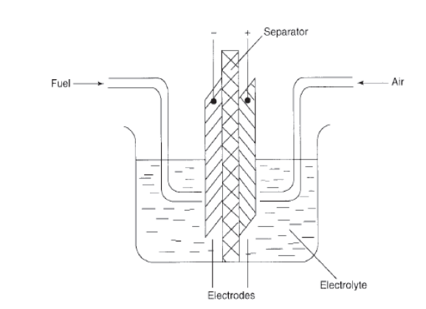

*Figure 2.1: Schematic of a Fuel Cell*

Unit cells form the core of a fuel cell it involves the conversion of chemical energy contained in a fuel electrochemically into electrical energy. There are many types of fuel cells, but they all consist of an [anode](https://en.wikipedia.org/wiki/Anode), a [cathode](https://en.wikipedia.org/wiki/Cathode), and an [electrolyte](https://en.wikipedia.org/wiki/Electrolyte) that allows ions, often positively charged hydrogen ions (protons), to move between the two sides of the fuel cell. At the anode a catalyst causes the fuel to undergo oxidation reactions that generate ions (often positively charged hydrogen ions) and electrons. The ions move from the anode to the cathode through the electrolyte. At the same time, electrons flow from the anode to the cathode through an external circuit, producing [direct current](https://en.wikipedia.org/wiki/Direct_current) electricity. At the cathode, another catalyst causes ions, electrons, and oxygen to react, forming water and possibly other products.

The different types of fuel cell are classified base on the following factors.

* The electrolyte substance, which usually defines the *type* of fuel cell, and can be made from a number of substances like potassium hydroxide, salt carbonates, and phosphoric acid.
* The fuel that is used. The most common fuel is hydrogen.
* The anode catalyst, usually fine platinum powder, breaks down the fuel into electrons and ions.
* The cathode catalyst, often nickel, converts ions into waste chemicals, with water being the most common type of waste.
* Gas diffusion layers that are designed to resist oxidization.

A typical fuel cell produces a voltage from 0.6 to 0.7 V at full rated load. Voltage decreases as current increases, due to several factors:

* [Activation loss](https://en.wikipedia.org/wiki/Overpotential)
* Ohmic loss ([voltage drop](https://en.wikipedia.org/wiki/Voltage_drop) due to resistance of the cell components and interconnections)
* Mass transport loss (depletion of reactants at catalyst sites under high loads, causing rapid loss of voltage).

To deliver the desired amount of energy, the fuel cells can be combined in [series](https://en.wikipedia.org/wiki/Series_and_parallel_circuits) to yield higher [voltage](https://en.wikipedia.org/wiki/Voltage), and in parallel to allow a higher [current](https://en.wikipedia.org/wiki/Electric_current) to be supplied. Such a design is called a *fuel cell stack*. The cell surface area can also be increased, to allow higher current from each cell.

The different types of fuel cell include: Proton-exchange membrane fuel cell (PEMFC), Phosphoric acid fuel cell (PAFC), Solid acid fuel cell (SAFC), Alkaline fuel cell (AFC), High temperature Fuel cell (HTFC), Electric storage fuel cell (ESFC).

**Proton-Exchange Membrane Fuel Cell**

In the archetypical hydrogen–oxide [proton-exchange membrane fuel cell](https://en.wikipedia.org/wiki/Proton-exchange_membrane_fuel_cell) (PEMFC) design, a proton-conducting polymer membrane (typically [nafion](https://en.wikipedia.org/wiki/Nafion)) contains the [electrolyte](https://en.wikipedia.org/wiki/Electrolyte) solution that separates the [anode](https://en.wikipedia.org/wiki/Anode) and [cathode](https://en.wikipedia.org/wiki/Cathode) sides (Dupuis 2011). On the anode side, hydrogen diffuses to the anode catalyst where it later dissociates into protons and electrons. These protons often react with oxidants causing them to become what are commonly referred to as multi-facilitated proton membranes. The protons are conducted through the membrane to the cathode, but the electrons are forced to travel in an external circuit (supplying power) because the membrane is electrically insulating. On the cathode catalyst, oxygen [molecules](https://en.wikipedia.org/wiki/Molecule) react with the electrons (which have traveled through the external circuit) and protons to form water.

In addition to this pure hydrogen type, there are [hydrocarbon](https://en.wikipedia.org/wiki/Hydrocarbon) fuels for fuel cells, including [diesel](https://en.wikipedia.org/wiki/Diesel_fuel), [methanol](https://en.wikipedia.org/wiki/Methanol) and chemical hydrides. The waste products with these types of fuel are [carbon dioxide](https://en.wikipedia.org/wiki/Carbon_dioxide) and water. When hydrogen is used, the CO2 is released when methane from natural gas is combined with steam, in a process called [steam methane reforming](https://en.wikipedia.org/wiki/Steam_reforming), to produce the hydrogen. This can take place in a different location to the fuel cell, potentially allowing the hydrogen fuel cell to be used indoors

**Phosphoric Acid Fuel Cell**

Phosphoric acid fuel cells (PAFC) were first designed and introduced in 1961 by [G. V. Elmore](https://en.wikipedia.org/w/index.php?title=G._V._Elmore&action=edit&redlink=1) and [H. A. Tanner](https://en.wikipedia.org/w/index.php?title=H._A._Tanner&action=edit&redlink=1). In these cells phosphoric acid is used as a non-conductive electrolyte to pass positive hydrogen ions from the anode to the cathode. These cells commonly work in temperatures of 150 to 200 degrees Celsius. This high temperature will cause heat and energy loss if the heat is not removed and used properly. This heat can be used to produce steam for air conditioning systems or any other thermal energy consuming system. Phosphoric acid, the electrolyte used in PAFCs, is a non-conductive liquid acid which forces electrons to travel from anode to cathode through an external electrical circuit. Since the hydrogen ion production rate on the anode is small, platinum is used as catalyst to increase this ionization rate. A key disadvantage of these cells is the use of an acidic electrolyte. This increases the corrosion or oxidation of components exposed to phosphoric acid.

**Solid Acid Fuel Cell**

Solid acid fuel cells (SAFCs) are characterized by the use of a solid acid material as the electrolyte. At low temperatures, [solid acids](https://en.wikipedia.org/wiki/Solid_acid) have an ordered molecular structure like most salts. At warmer temperatures (between 140 and 150 °C for CsHSO4), some solid acids undergo a phase transition to become highly disordered "superprotonic" structures, which increases conductivity by several orders of magnitude. The first proof-of-concept SAFCs were developed in 2000 using cesium hydrogen sulfate (CsHSO4) (Haile 2001). Current SAFC systems use cesium dihydrogen phosphate (CsH2PO4) and have demonstrated lifetimes in the thousands of hours (Haile 2006).

**Alkaline Fuel Cell**

The alkaline fuel cell (AFC) or hydrogen-oxygen fuel cell consists of two porous carbon electrodes impregnated with a suitable catalyst such as Pt, Ag, and CoO. The space between the two electrodes is filled with a concentrated solution of [KOH](https://en.wikipedia.org/wiki/Potassium_hydroxide) or [NaOH](https://en.wikipedia.org/wiki/Sodium_hydroxide) which serves as an electrolyte. H2 gas and O2 gas are bubbled into the electrolyte through the porous carbon electrodes. Thus the overall reaction involves the combination of hydrogen gas and oxygen gas to form water. The cell runs continuously until the reactant's supply is exhausted. This type of cell operates efficiently in the temperature range 343–413 K and provides a potential of about 0.9 V. (Srivastava 2014). [Alkaline anion exchange membrane fuel cell](https://en.wikipedia.org/wiki/Alkaline_anion_exchange_membrane_fuel_cell) (AAEMFC) is a type of AFC which employs a solid polymer electrolyte instead of aqueous potassium hydroxide (KOH) and it is superior to aqueous AFC.

**High Temperature Fuel Cell**

The high temperature fuel cell comprises of the following:

* **Solid Oxide fuel Cell:** [Solid oxide fuel cells](https://en.wikipedia.org/wiki/Solid_oxide_fuel_cell) (SOFCs) use a solid material, most commonly a ceramic material called [yttria-stabilized zirconia](https://en.wikipedia.org/wiki/Yttria-stabilized_zirconia) (YSZ), as the [electrolyte](https://en.wikipedia.org/wiki/Electrolyte). Because SOFCs are made entirely of solid materials, they are not limited to the flat plane configuration of other types of fuel cells and are often designed as rolled tubes. They require high [operating temperatures](https://en.wikipedia.org/wiki/Operating_temperature) (800–1000 °C) and can be run on a variety of fuels including natural gas. SOFCs are unique since in those, negatively charged oxygen [ions](https://en.wikipedia.org/wiki/Ion) travel from the [cathode](https://en.wikipedia.org/wiki/Cathode) (positive side of the fuel cell) to the [anode](https://en.wikipedia.org/wiki/Anode) (negative side of the fuel cell) instead of positively charged hydrogen ions travelling from the anode to the cathode, as is the case in all other types of fuel cells. Oxygen gas is fed through the cathode, where it absorbs electrons to create oxygen ions. The oxygen ions then travel through the electrolyte to react with hydrogen gas at the anode. The reaction at the anode produces electricity and water as by-products. (Boudghene 2002)
* **Molten Carbonate Fuel Cell:** [Molten carbonate fuel cells](https://en.wikipedia.org/wiki/Molten_carbonate_fuel_cell) (MCFCs) require a high operating temperature, 650 °C (1,200 °F), similar to [SOFCs](https://en.wikipedia.org/wiki/Solid_oxide_fuel_cell). MCFCs use lithium potassium carbonate salt as an electrolyte, and this salt liquefies at high temperatures, allowing for the movement of charge within the cell – in this case, negative carbonate ions (Energy.Gov 2022). Like SOFCs, MCFCs are capable of converting fossil fuel to a hydrogen-rich gas in the anode, eliminating the need to produce hydrogen externally. The reforming process creates CO2 emissions. MCFC-compatible fuels include natural gas, biogas and gas produced from coal. The hydrogen in the gas reacts with carbonate ions from the electrolyte to produce water, carbon dioxide, electrons and small amounts of other chemicals. The electrons travel through an external circuit creating electricity and return to the cathode. There, oxygen from the air and carbon dioxide recycled from the anode react with the electrons to form carbonate ions that replenish the electrolyte, completing the circuit (Energy.Gov 2022)

**Electric Storage Fuel Cell**

The electric storage fuel cell is a conventional battery chargeable by electric power input, using the conventional electro-chemical effect. However, the battery further includes hydrogen (and oxygen) inputs for alternatively charging the battery chemically (US Patent 2013).

**2.3 GRID CONNECTED HYBRID RENEWABLE ENERGY SYSTEMS**

An electrical grid is an interconnected network for [electricity delivery](https://en.wikipedia.org/wiki/Electricity_delivery) from producers to consumers (Kaplan 2009). A grid-connected system allows you to power your home or business with renewable energy during those periods (daily as well as seasonally) when the sun is shining, the water is running, or the wind is blowing.

Hybrid systems, as the name implies, combine two or more modes of electricity generation together, usually using renewable technologies such as solar photovoltaic (PV) and wind turbines. Hybrid systems provide a high level of energy security through the mix of generation methods, and often will incorporate a storage system (battery, [fuel cell](https://en.wikipedia.org/wiki/Fuel_cell)) or small fossil fueled generator to ensure maximum supply reliability and security (Kamal 2018). Hence a hybrid energy system, or hybrid power, usually consists of two or more renewable energy sources used together to provide increased system efficiency as well as greater balance in energy supply. Hybrid system or hybrid power results from the fact that each sources of renewable energy has their own drawbacks, for example; Solar panels are expensive to set up, and the peak output is not obtained during the night or cloudy days. Similarly, Wind turbines can’t operate safely in high wind speeds, and low wind speeds produce little power. Hydro power is affected by seasonal change. So if all the three are combined into one hybrid power generating system the drawbacks can be avoided partially/completely, depending on the control units, as the one or more drawbacks can be overcome by the other. Different types of grid-connected hybrid system are dicussed below.

**2.3.1 Solar PV/ Fuel Cell Hybrid Connected System by Th.F. El-Shatter, M.N. Eskandar, M.T. El-Hagry**

The design focuses on a 2.24 kW PV-fuel cell hybrid generation system. An electrolyzer coupled to the PV array is employed for hydrogen production. Maximum power tracking for PV array is achieved using fuzzy regression. A controller is designed to ensure continuous constant power generation through the day and after sunset via the PV and fuel cell stack. For the protection of the electrolyzer electrodes, a novel H2 storage device is used to isolate the electrolyte from the electrolysis cell and inject N2 to protect electrodes from corrosion. The figure below shows a PV-FC generation system.

The major components of the system are: a polycrystalline PV array Solarex module type MSX-56, a Unipolar Stuart cell electrolyzer, a hydrogen storage tank, proton exchange membrane (PEM) fuel cell stack, and the 72 dc V, 31A load. A control system is employed to monitor the state of the system, and control power and hydrogen flows.

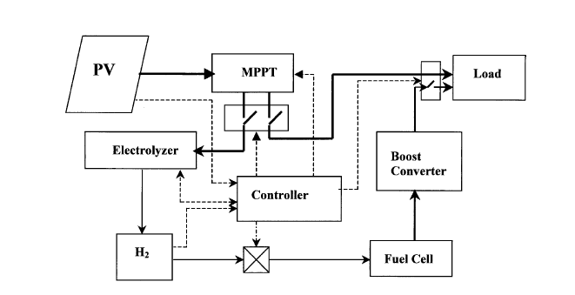

*Figure 2.1: Isolated Hybrid PV – FC generation system*

**PV Subsystem**

The power generation system with a PV system has two application types: a local (isolated) type and an interconnected (grid connected) type. The isolated type system works independent of other power systems, where the load locally consumes the electric power from the PV system. The output power of the PV system, however, fluctuates depending on solar insolation and surface temperature. Then a storage system must be used to deliver the required power at lower insolation levels and during the night. The MPP voltage and current *V*m, *I*m respectively are determined on-line using FRM. The determined MPP current is fed to the electrolyzer model to calculate the amount of H2 generated. The H2 is fed with the amount of air required for FC operation.

**Electrolyzer Subsystem**

The Unipolar Stuart cell is a high efficiency low maintenance, rugged and reliable cell. Each electrode has a single polarity producing either $H_{2}$ (cathode) or $O_{2}$ (anode). The electrolyzer consists of a number of cells isolated from one another in separate cell compartments. Cell voltage under normal operating conditions are in the range of 1.7–1.9 V. Circulation of the electrolyte is facilitated by the $H_{2}$ and $O_{2}$ gases rising in the channels formed between the respective electrodes and cell separator. The operating temperature of the electrolyzer does not exceed 70°C, thus reducing the material constraints. $H_{2}$ is directly produced at 99.9% purity. Also the current efficiency is 100%, and hence the hydrogen production rate is:

$$X_{HZ}={5.18e}^{-6}I_{e}Mole/s$$

Where $I_{e}$ is the current between electrodes. $H_{2}$ is stored at 3 bar in a tank to feed the FC at low insolation levels and hence supply the required load power.

However, an important factor affects the electrolysis process, which should be considered in the system design. This factor takes place after sunset when the electrolyzer current drops to zero, which means that the electrolyzer must be kept under protective voltage in order to prevent the cathodic potentials from being excessively attacked by active corrosion. To overcome this defect, the proposed electric storage device is designed to isolate the electrolyte from the electrolysis cell and inject $N_{2}$ to the electrolyzer to protect electrodes from corrosion

**FC Subsystem**

Proton Exchange Membrane (PEM) fuel cells stack is used. The PEM uses a polymer membrane as its electrolyte. With such solid polymer electrolyte, electrolyte loss is not an issue with regard to stack life. $H_{2}$ produced by the electrolyzer is consumed at the anode, yielding electrons at the anode and producing $H_{2}$ ions, which enter the electrolyte. At the cathode, H2 combines with $H_{2}$ ions to produce water, which is rejected from the back of the cathode into the oxidant gas stream as the PEM operates at 75°C water produced is carried out of the FC by excess oxidant flow.

In the proposed system air is used as the oxidant, cell pressure is atmospheric and cell temperature 70°C. Current density is designed as 400 mA / cm2. This leads to the use of 90 fuel cells in a stack. At atmospheric pressure, Nernest equation relates the electrical performance of the FC to the state variables:

$$V_{o}= E_{o}+ \frac{R.T}{2F}1n\frac{x_{H_{2}}x_{O_{2}^{0.5}}}{x_{H_{2}O}}$$

Where

$V_{o}$ Open circuit reversible cell potential (V)

$E_{o}$ Standard reversible cell potential (V)

$X_{i}$ Mole fractions of species (g mole)

Under load cell voltages are affected by ohmic losses, anode and cathode polarization, and temperature. Neglecting polarization losses, the cell voltage under load is:

$$V= V_{o}-iAR-b log⁡(iA)$$

Where

$i$ Current density

*A* cell area

*R* ohmic resistance

*b* Tafel slope

**2.3.2 Solar PV and Fuel Cell Based Hybrid Power System by Manish Kumar Singla, Parag Nijhawan, Amandeep Singh Oberoi.**

The schematic of the solar PV-fuel cell based hybrid system is shown in the Figure 2.2. The components used in the proposed system are PV array, a modified unitized regenerative fuel cell (URFC) system, dump load, inverter, electrical load and bus system. The output of solar PV array is fed to a DC bus in a day-light or when sun is available. When power from any of the systems is accessible, it runs the electronic load and any surplus power produce during peak hours could be used to drive a URFC in electrolyser mode to split water into oxygen and hydrogen. The generated hydrogen could be stored and reused to generate electricity through the same URFC but, running in fuel cell mode during night or when sun is not available. The converter circuit converts the DC power generated from solar PV cells module into AC to meet the load demand. The DC loads are directly fed from the DC bus. Although the proposed system runs similar to the conventional PV & fuel cell based hybrid systems however, the new design offers additional advantages.

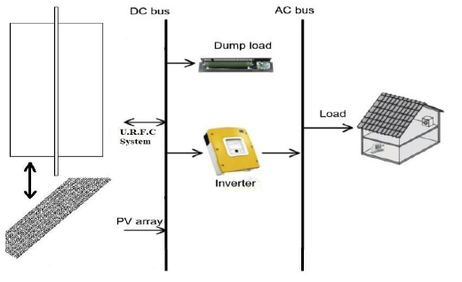

*Figure 2.2: Schematic of the solar PV-Fuel cell hybrid system*

**The Hybrid System**

Generally, the concept of a solar-PV & fuel cell based hybrid system work as an independent unit connected to a DC bus which lowers the overall energy harness output per $m^{2}$ of the land occupied. Therefore, a novel design of PV & fuel cell based hybrid system could better utilize the existing space in terms of productivity enhancement and energy/ $m^{2}$ harnessed from the utilized land.

Moreover, the tilted (angled) design of solar PV array would avoid shadow and hence, provide maximum time and intensity of sunlight exposure thereby generating more power.

**Unitized Regenerative Fuel Cell**

A unitized regenerative fuel cell or URFC is a single unit capable of operating in both electrolyzer and fuel cell modes.

This individual URFC unit replaces the separate fuel cell and electrolyzer in a conventional hydrogen system. In this hydrogen system, URFC uses direct current while operating in electrolysis mode to split water into hydrogen and oxygen. The hydrogen produced in the electrolysis mode is pressurized and stored in a separate storage unit. While operating in fuel cell mode, the URFC combines hydrogen and oxygen to produce electricity and water. The hydrogen required for URFC is supplied from the storage unit. Figure 2.3 shows the schematic of this hydrogen system with URFC.

URFC used in the system must be comparable in terms of both efficiency and lifetime, compared to the commercially available electrolyzers and fuel cells. Purchasing a single URFC cell is economically advantageous because it reduces the cost of purchasing separate electrolyzers and fuel cells. The performance of PEM URFC can be achieved in the vicinity of special electrolyzers and fuel cells, but URFC has short term limitations that it will decline after several hundred cycles.

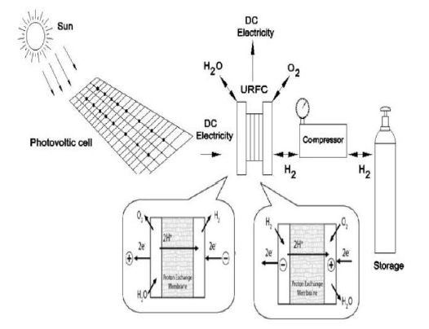

*Figure 2.3: Schematic of a Hydrogen system with URFC*

A concern when using a hydrogen system with URFC is that an external hydrogen storage unit is required to store the generated hydrogen. However, the current research work is a maiden attempt to ascertain the technical feasibility of a solar PV and fuel cell-based (URFC in this case) hybrid system. The obtained results have shown that the average solar irradiation that incidents on the selected site is enough to generate electricity through photovoltaic cells and simultaneously run a URFC to produce hydrogen from water, when sun is available. There is enough excess DC current available during peak hours to be used to disassociate water in a URFC and store the produced hydrogen as well as oxygen for later use. During the times when sun is not available, the stored reactants (hydrogen and oxygen gases) could be fed back to the URFC to give out electricity and water. Compared to the conventional system of hydrogen generation through renewable, the proposed system offers more round-the-trip efficiency i.e. electricity in to electricity out; due to lesser number of components and associated losses.

**2.3.3 Hybrid PV-Micro Hydro Power System by Getnet Zewde Samano and Getachew Shunki**

The design research focuses on a stand-alone off grid solar and micro hydropower system which consists of a charging system, battery storage system, and a power conversion system.

The hybrid system consists of a solar and micro-hydro renewable combination along a power generator which acts as the supplement. The capability of the electric power generating hybrid systems is to satisfy the power demand on the atmospheric conditions. Such conditions will define different operation modes of the system. These operation modes are determined by the energy balance between the total generation and the total demand, the combination has to be formulated for the efficient investment and operation of the system, figure2.4 described the blocked diagram of hybrid PV-micro hydro System.

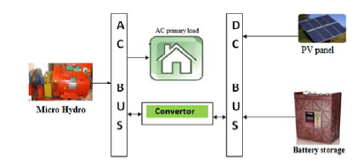

*Figure 2.4: Blocked Diagram of Hybrid PV-Micro Hydro System.*

This can be characterized as a mixed ac/dc bus hybrid system with some energy sources connected to the dc bus and others connected to the ac bus. Usually the PV array is connected to the dc bus via a battery charge controller, which initially was of the series pulse-width modulation (PWM) type.

However ac bus connection of PV is also possible with some systems. Micro hydro power is connected to the AC bus via a transfer switch integrated into the inverter/charger and the inverter/charger controls. The proposed work includes both an AC/DC rectifier and DC/AC inverter. The exciting of PV is DC supply, and the exciting of micro hydro power is AC to make Hybrid. PV and battery are converted from the DC to AC and then connected to AC bus; in block schematic diagram the power conditioner is included in the hydro turbine and PV panel. There are three power options in Figure 2.4 (hydro, solar and storage batteries) PV and micro hydro power are synchronized together with PV and storage battery after converting.

**2.3.4 Grid Connected DC Linked PV/Hydro Hybrid System by Sweeka Meshram, Ganga Agnihotri and Sushma Gupta.**

The design focuses on the simulation and modelling of a grid connected DC linked PV/Hydro hybrid system. Figure 2.5 shows the schematic diagram of the grid connected DC linked PV/Hydro hybrid system. The DC bus of the PV and hydro system has been common linked to reduce the cost and complexity of the hybrid system. The hybrid system acts as a dominant system and power grid will be acts as a standby to compensate the deficit in the hybrid system. In rainy days/night, the solar energy will be unavailable, hence the power requirement will fulfilled by hydro system and power grid. In summer, the hydro power will be less; in that case the power requirement will be fulfilled by the PV system and power grid. In other days, the power will be fed by the PV/Hydro hybrid system. Thus, the power requirement throughout the year can be satisfied by the proposed system. The proposed system was tested under the linear resistive, RL and Induction Motor (IM) as a dynamic load.

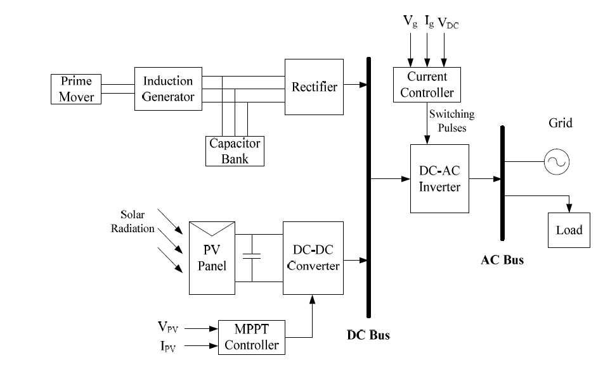

*Figure 2.5: Schematic diagram of grid connected DC linked PV/Hydro Hybrid system*

**The Hydro System**

Figure 2.6 depicts the schematic diagram of the hydro power plant. A 3-phase, ∆-connected induction machine has been used for converting hydro power into electrical power. The induction machine driven by constant speed prime mover is used and operated as a Self Excited Induction Generator (SEIG). The reactive power requirement of the SEIG is met by the 3-phase excitation capacitor bank connected across the stator terminals. The elementary difficulty with the SEIG is its incapability to control the generated terminal voltage and frequency under varying load condition. An external source of reactive current is required for terminal voltage regulation of the SEIG with varying load and to utilize the machine to its rated capacity. The utility grid is considered as a reactive current source for SEIG.

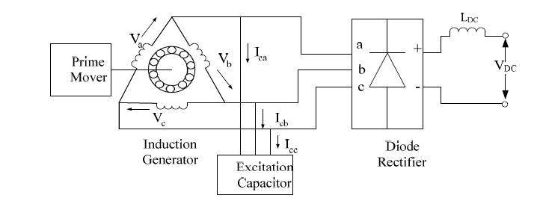

*Figure 2.6: Schematic Diagram of Hydro Power Plant*

**PV System**

Figure 2.7 depicts the schematic diagram of the solar power plant. The solar power plant consists of PV panel, boost converter and MPPT controller. The PV panel is the series and parallel combination of the PV modules. A high valued capacitor CB is connected across the PV panel terminal to reduce the harmonics, which is generated due to variation in temperature and solar irradiation.

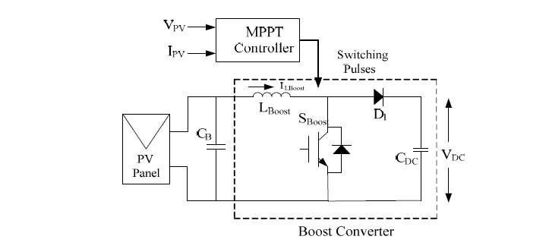

*Figure 2.7: Schematic Diagram of Solar Power Plant*

The generated DC voltage of the PV panel is very low for the application. Hence, the generated

DC voltage level is increased using the DC-DC boost converter. The boost converter simply controls the output voltage of the PV panel ($V_{pv}$) to a constant dc link voltage ($V_{DC}$). The converter also performs the MPPT function for acquiring high energy conversion efficiency. The

MPPT controller uses the Incremental conductance with Integral Regulator MPPT technique by considering the PV panel voltage and current.

The modeling of the DC-DC converter depends on the various sequences of operation by controlling the duty ratio D. There are two sequence of operation of converter depending on the state of the IGBT switch (SB).

The PV array can be controlled for obtaining the maximum power point by the regular correction in duty ratio (D), which is obtained by the MPPT controller. The MPPT controller also controls the D, for maintaining the regular voltage using the reference voltage and generates the control signal for the converter switch SB.

**Grid Interfacing Inverter**

To reduce the overall cost of the system the DC link of both hydro and solar power plant is integrated. To feed the AC load or to inject the real power to the utility grid the DC-AC power conversion is carried out using the grid interfacing bridge inverter. Figure 4 shows the simplified circuit of the grid interfacing inverter.

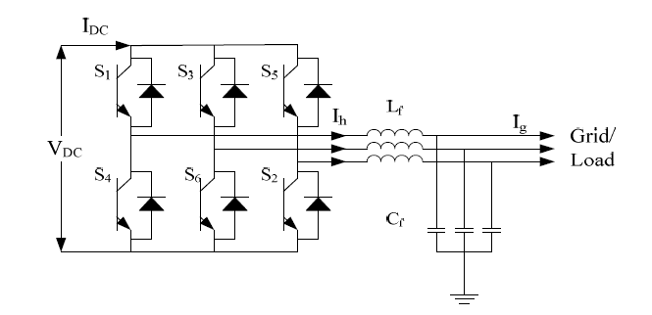

*Figure 2.8: Simplified circuit of grid interfacing inverter*